README

Fanuc MTConnect Agent with integrated Focas back-end adapter. The Install script with copy the agent exe and config files to the folder: C:\Program Files\MTConnect\MTConnectFanucAgent, then install agent as the service MTCFanucAgent, and start the agent.

To install:

Double click: FanucAgentInstall.msi

1) Select Focas connection to CNC: either High Speed Serial Bus (HSSB) or Ethernet

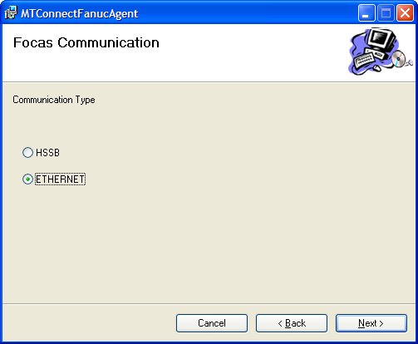

2) Configure next options:

a) If Ethernet, input CNC IP Address.

b) If other than port 80 for http, input new port

c) input machine configuration: xyz, xyza, xyzbc, etc.

